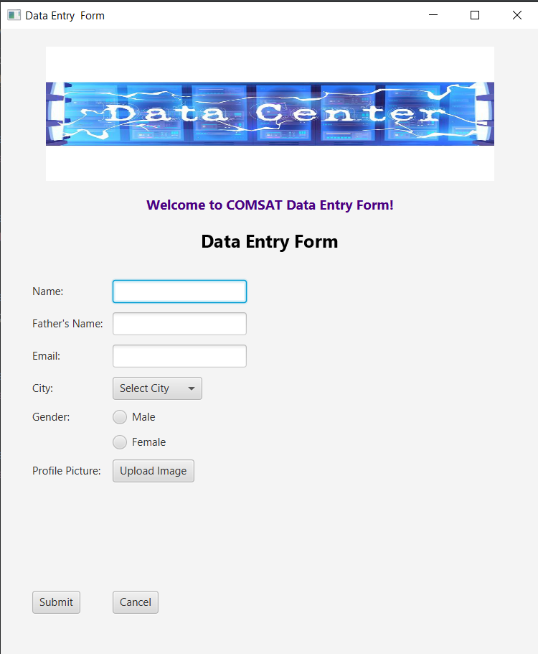

**Code**

package com.example.dayaform;  
  
import javafx.application.Application;  
import javafx.fxml.FXMLLoader;  
import javafx.scene.Scene;  
import javafx.stage.Stage;  
  
import java.io.IOException;  
  
import javafx.application.Application;  
import javafx.geometry.Insets;  
import javafx.geometry.Pos;  
import javafx.scene.Scene;  
import javafx.scene.control.*;  
import javafx.scene.image.Image;  
import javafx.scene.image.ImageView;  
import javafx.scene.layout.*;  
import javafx.scene.paint.Color;  
import javafx.scene.text.Font;  
import javafx.scene.text.Text;  
import javafx.stage.FileChooser;  
import javafx.stage.Stage;  
  
import java.io.File;  
import java.util.ArrayList;  
  
import javafx.application.Application;  
import javafx.geometry.Insets;  
import javafx.geometry.Pos;  
import javafx.scene.Scene;  
import javafx.scene.control.*;  
import javafx.scene.image.Image;  
import javafx.scene.image.ImageView;  
import javafx.scene.layout.*;  
import javafx.stage.FileChooser;  
import javafx.stage.Stage;  
  
import java.io.File;  
import java.util.ArrayList;  
  
import javafx.application.Application;  
import javafx.geometry.Insets;  
import javafx.geometry.Pos;  
import javafx.scene.Scene;  
import javafx.scene.control.*;  
import javafx.scene.image.Image;  
import javafx.scene.image.ImageView;  
import javafx.scene.layout.*;  
import javafx.scene.text.Text;  
import javafx.stage.FileChooser;  
import javafx.stage.Stage;  
  
import java.io.File;  
import java.util.ArrayList;  
  
public class HelloApplication extends Application {  
  
 private File selectedImage; // To store uploaded profile picture  
 private final ArrayList<UserData> userDataList = new ArrayList<>(); // Store submitted data  
  
 @Override  
 public void start(Stage stage) {  
  
 Image bannerImage = new Image("https://i.pinimg.com/736x/3c/28/28/3c282815b8dd88d3566822ea5a9aa2b6.jpg");  
 ImageView bannerView = new ImageView(bannerImage);  
 bannerView.setFitWidth(500);  
 bannerView.setFitHeight(150);  
  
  
 Label welcomeMessage = new Label("Welcome to COMSAT Data Entry Form!");  
 welcomeMessage.setStyle("-fx-font-size: 15px; -fx-font-weight: bold; -fx-text-fill: indigo;");  
 welcomeMessage.setAlignment(Pos.*CENTER*);  
  
 Text formTitle = new Text("Data Entry Form");  
 formTitle.setStyle("-fx-font-size: 20px; -fx-font-weight: bold; -fx-fill: black;");  
  
  
 Label nameLabel = new Label("Name:");  
 TextField nameField = new TextField();  
  
 Label fatherNameLabel = new Label("Father's Name:");  
 TextField fatherNameField = new TextField();  
  
 Label emailLabel = new Label("Email:");  
 TextField emailField = new TextField();  
  
 // Dropdown for Cities  
 Label cityLabel = new Label("City:");  
 ComboBox<String> cityComboBox = new ComboBox<>();  
 cityComboBox.getItems().addAll("Lahore", "Karachi", "Islamabad", "Multan", "Murree");  
 cityComboBox.setPromptText("Select City");  
  
 // Gender Selection  
 Label genderLabel = new Label("Gender:");  
 ToggleGroup genderGroup = new ToggleGroup();  
 RadioButton maleRadio = new RadioButton("Male");  
 RadioButton femaleRadio = new RadioButton("Female");  
 maleRadio.setToggleGroup(genderGroup);  
 femaleRadio.setToggleGroup(genderGroup);  
  
  
 Label imageLabel = new Label("Profile Picture:");  
 Button uploadButton = new Button("Upload Image");  
 ImageView imageView = new ImageView();  
 imageView.setFitWidth(100);  
 imageView.setFitHeight(100);  
  
 uploadButton.setOnAction(e -> {  
 FileChooser fileChooser = new FileChooser();  
 fileChooser.getExtensionFilters().add(new FileChooser.ExtensionFilter("Image Files", "*.png", "*.jpg", "*.jpeg"));  
 selectedImage = fileChooser.showOpenDialog(stage);  
 if (selectedImage != null) {  
 Image image = new Image(selectedImage.toURI().toString());  
 imageView.setImage(image);  
 }  
 });  
  
  
 Button submitButton = new Button("Submit");  
 Button cancelButton = new Button("Cancel");  
  
 submitButton.setOnAction(e -> {  
 submitButton.setStyle("-fx-background-color: pink;");  
 handleSubmit(nameField.getText(), fatherNameField.getText(), emailField.getText(),  
 cityComboBox.getValue(), genderGroup.getSelectedToggle() != null  
 ? ((RadioButton) genderGroup.getSelectedToggle()).getText()  
 : null,  
 selectedImage != null ? selectedImage.getPath() : "No Image");  
 });  
  
 cancelButton.setOnAction(e -> {  
 cancelButton.setStyle("-fx-background-color: Red;");  
 stage.close();  
 });  
  
   
 GridPane gridPane = new GridPane();  
 gridPane.setPadding(new Insets(15));  
 gridPane.setHgap(10);  
 gridPane.setVgap(10);  
  
 gridPane.add(nameLabel, 0, 0);  
 gridPane.add(nameField, 1, 0);  
 gridPane.add(fatherNameLabel, 0, 1);  
 gridPane.add(fatherNameField, 1, 1);  
 gridPane.add(emailLabel, 0, 2);  
 gridPane.add(emailField, 1, 2);  
 gridPane.add(cityLabel, 0, 3);  
 gridPane.add(cityComboBox, 1, 3);  
 gridPane.add(genderLabel, 0, 4);  
 gridPane.add(maleRadio, 1, 4);  
 gridPane.add(femaleRadio, 1, 5);  
 gridPane.add(imageLabel, 0, 6);  
 gridPane.add(uploadButton, 1, 6);  
 gridPane.add(imageView, 1, 7);  
 gridPane.add(submitButton, 0, 8);  
 gridPane.add(cancelButton, 1, 8);  
  
 VBox root = new VBox(15, bannerView, welcomeMessage, formTitle, gridPane);  
 root.setPadding(new Insets(20));  
 root.setAlignment(Pos.*TOP_CENTER*);  
  
 Scene scene = new Scene(root, 600, 700);  
 stage.setScene(scene);  
 stage.setTitle("Data Entry Form");  
 stage.show();  
 }  
  
 private void handleSubmit(String name, String fatherName, String email, String city, String gender, String imagePath) {  
 if (name.isEmpty() || fatherName.isEmpty() || email.isEmpty() || city == null || gender == null) {  
 showAlert("Error", "All fields are required!", Alert.AlertType.*ERROR*);  
 } else {  
 UserData data = new UserData(name, fatherName, email, city, gender, imagePath);  
 userDataList.add(data);  
 showAlert("Success", "Data Submitted Successfully!", Alert.AlertType.*INFORMATION*);  
 displaySubmittedData();  
 }  
 }  
  
 private void displaySubmittedData() {  
 Stage displayStage = new Stage();  
 VBox vbox = new VBox(15);  
 vbox.setPadding(new Insets(20));  
  
 for (UserData data : userDataList) {  
 Label userLabel = new Label(  
 "Name: " + data.getName() + "\n" +  
 "Father's Name: " + data.getFatherName() + "\n" +  
 "Email: " + data.getEmail() + "\n" +  
 "City: " + data.getCity() + "\n" +  
 "Gender: " + data.getGender() + "\n" +  
 "Image Path: " + data.getImagePath()  
 );  
 userLabel.setStyle("-fx-font-size: 14px; -fx-border-color: black; -fx-padding: 10px; -fx-text-fill: indigo;");  
 vbox.getChildren().add(userLabel);  
 }  
  
 Scene scene = new Scene(vbox, 400, 300);  
 displayStage.setScene(scene);  
 displayStage.setTitle("Submitted Data");  
 displayStage.show();  
 }  
  
 private void showAlert(String title, String message, Alert.AlertType alertType) {  
 Alert alert = new Alert(alertType);  
 alert.setTitle(title);  
 alert.setHeaderText(null);  
 alert.setContentText(message);  
 alert.showAndWait();  
 }  
  
 public static void main(String[] args) {  
 *launch*(args);  
 }  
  
 static class UserData {  
 private final String name;  
 private final String fatherName;  
 private final String email;  
 private final String city;  
 private final String gender;  
 private final String imagePath;  
  
 public UserData(String name, String fatherName, String email, String city, String gender, String imagePath) {  
 this.name = name;  
 this.fatherName = fatherName;  
 this.email = email;  
 this.city = city;  
 this.gender = gender;  
 this.imagePath = imagePath;  
 }  
  
 public String getName() {  
 return name;  
 }  
  
 public String getFatherName() {  
 return fatherName;  
 }  
  
 public String getEmail() {  
 return email;  
 }  
  
 public String getCity() {  
 return city;  
 }  
  
 public String getGender() {  
 return gender;  
 }  
  
 public String getImagePath() {  
 return imagePath;  
 }  
 }  
}